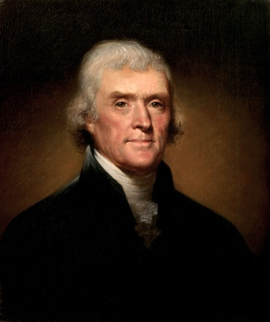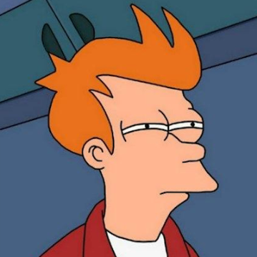File I/O Lab Rules:

Rule 1: Think before you program!

Rule 2: A program is a human-readable essay on problem solving that

also happens to execute on a computer.

Rule 3: The best way to improve your programming and problem solving skills is

to practice.

Rule 4: A foolish consistency is the hobgoblin of little minds.

Rule 5: Test your code, often and thoroughly!

You have been hired by some historians to perform an analysis of past presidential speeches. The group seeks to understand how the words used in political speeches have changed over time. They would like you to analyze a set of inauguration addresses made by US presidents and calculate the average length of each word in a speech, as well as the total number of words. Write a program which reads through a speech stored in a text file (examples provided ) and calculate this information. Print the results to the screen. Assume that the first line of each file is the name of the president who gave the speech and the second line is the date of the speech. Print this information along with your output.

Also analyze the difference of: length of speeches and the average length of the words in each speech. Were the speeches of different era's shorter, smaller words?

Test a few words (people, government, united, our) and see if they appear in all of the speeches. What percent and how many times do these words appear in each speech? There are many ways to do this. You could use a for loop and the charAt() method in the String class to find each word. You could use the split() function inside the string class. Scanner used as an iterator would also be helpful.

//comment on your thoughts on the data you find

Pick 2 speeches from each era: modern, 1830-1920, 1776 – 1830 's. You will analyze/run a total of 6 separate times. Change the file/speech each execution.

Inaugural addresses and speeches from some of our great (and not so great) presidents:

Files in Folder:

Thomas Jefferson,

John Adams,

William Taft,

Millard Fillmore,

Theodore Roosevelt

John F. Kennedy,

George W. Bush

Jimmy Carters crisis of confidence

Obama inaugural speech

**Submission:**

* Be sure your code has a comment with your name
* Print the code and your comments on the data you find.
* Print only ONE output